transfer.hpp - Manual Token Transfers Testing

**Tests in this scope relate to token transfers into the nft.scribe contract, to ensure they are deposited to the correct account. 1.nft started with 6 TLOS in it from previous transfers.**

**PASSED** - Send 105.0000 TLOS to newly created account with no balance, should pass

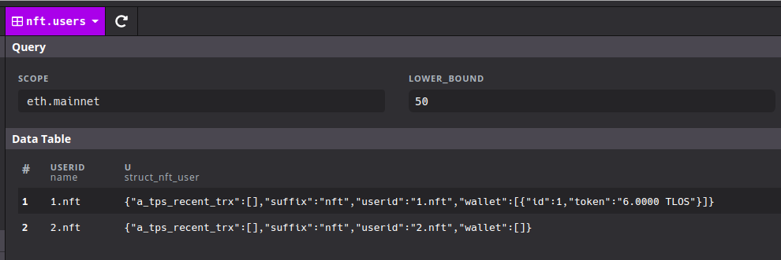

Send to 2.nft virtual account

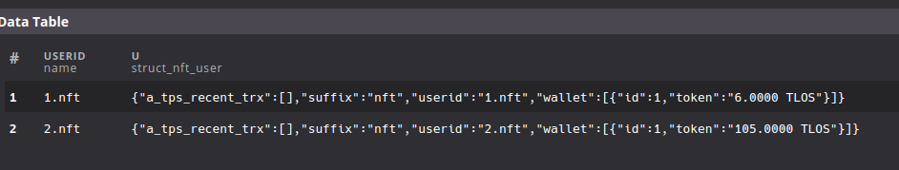

**PASSED** - Send 1.0000 TLOS to zz2.nft, should fail

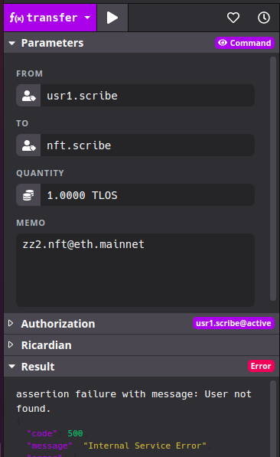

This fails because there is a specific username check, even though mathematically zz2 == 2 in the base 31 username system.

**PASSED** - Send 1,000.0000 TLOS to 1.nft, should pass

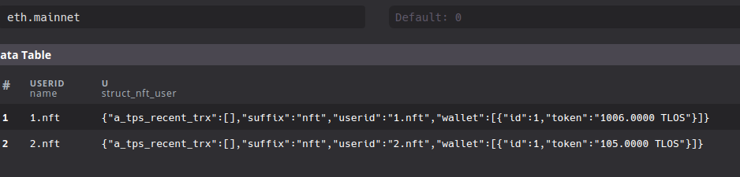

**PASSED** - Audit of Balances so far

1.nft = 1006 TLOS

2.nft = 105 TLOS

Total: 1111 TLOS

nftservices TABLE - passed

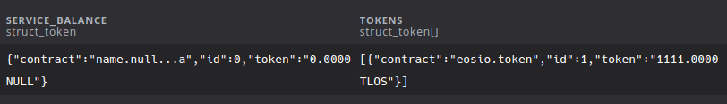

tokens TABLE - passed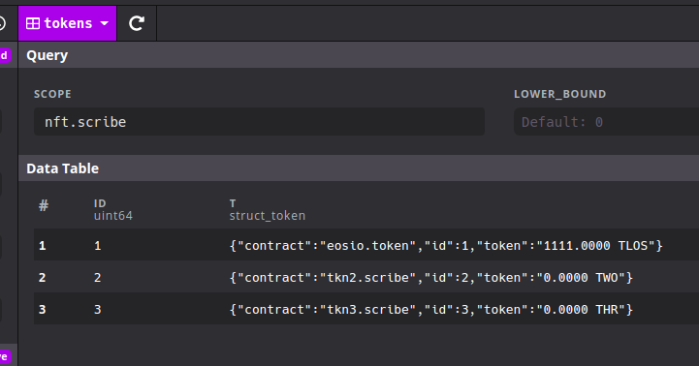

**PASSED** - Transfer Fake TLOS tkn1.scribe in of 500 to x.nft, should fail

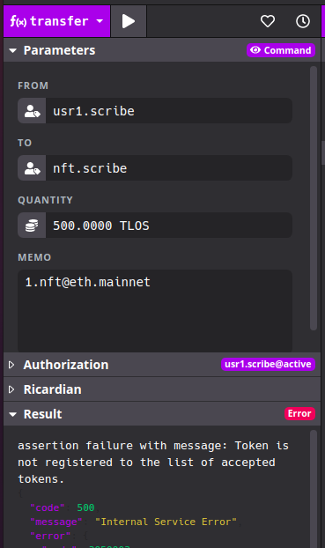 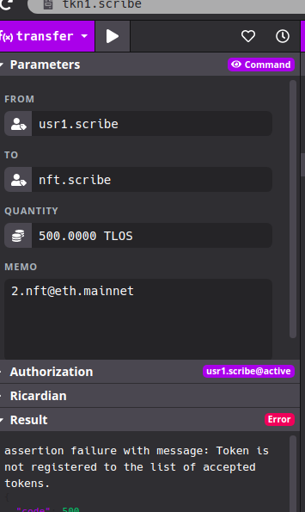

**PASSED** - Send 500 TLOS to wrong network bsc.mainnet, should fail

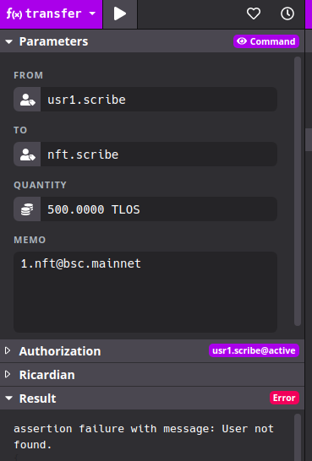

**PASSED** - Register a new token tkn2.scribe

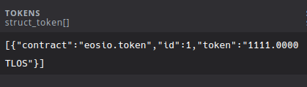

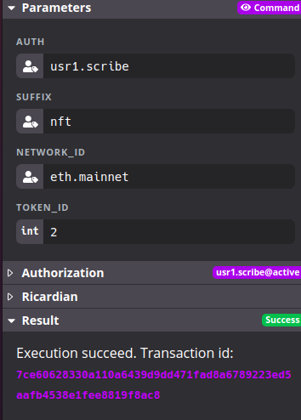

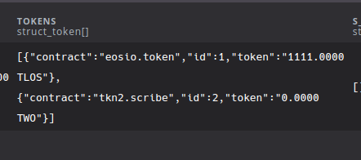

**PASSED** - Transfer in 200.0000 TWO to 2.nft, should pass

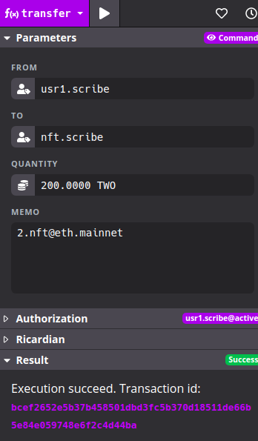

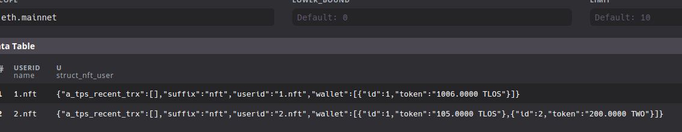

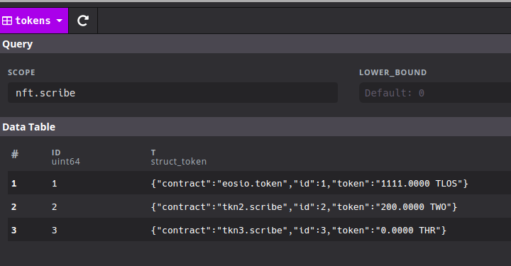

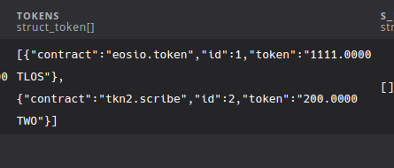

**PASSED** - Transfer Unregistered Network Token, should fail

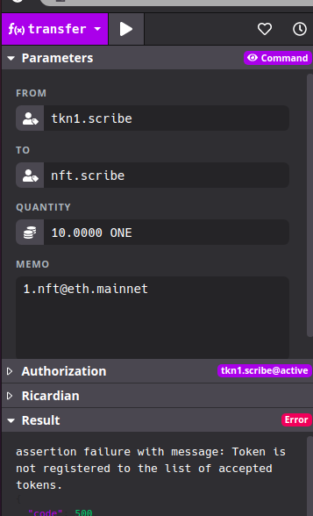

**PASSED** - Transfer Unregistered NFT Service Token, but registered by admins, should fail

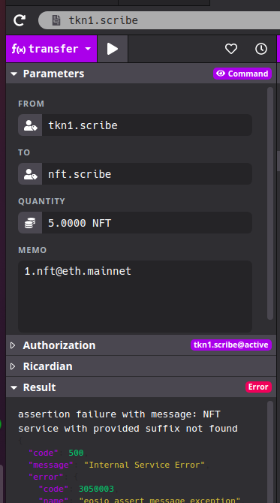

Checks for this are done whenever receiving a token, but not when a token is sent.